STATISTIC COMPUTATION
COMPOUND LINIER REGRESSION



KHEN MUHAMMAD CAHYO
244107023002
TI-2I
STATE POLYTECHNIC OF MALANG
INFORMATION TECHNOLOGY DEPARTMENT

STEP 1 – DATA COLLECTION
The data that used for this answers is car price data prediction from Kaggle on this link:
https://www.kaggle.com/code/muhammadglennyunifer/car-price-prediction-linear-regression/notebook

And here the link for spreadsheet results:
https://docs.google.com/spreadsheets/d/1ihEAN6-tDojuW7mEO5Zo8E37xuTbdW_uBS2JKoOgvPM/edit?usp=sharing

STEP 2 – VARIABLE SELECTION
- Dependent Variable
- Price
- Independent Variable

- Symboling
- Fueltype
- Aspiration
- DoorNumber
- CarBody
- DriveWheel
- EngineeLocation
- WheelBase
- CarLength
- CarWidth
- CarHeight
- CurbWeight
- EngineeType
- CylinderNumber
- EngineeSize
- FuelSystem
- BoreRatio
- Stroke
- CompressionRatio
- HorsePower
- PeakRPM
- CityMpg
- HighwayMpg

STEP 3 – REGRESSION ANALYSIS & INTERPRETATION RESULTS
In this variable relationship analysis. I analyzed the variable relationships that affect the value of the CityMPG variable. The following are the variables that are thought to affect the value of the CityMPG variable
- EngineeType
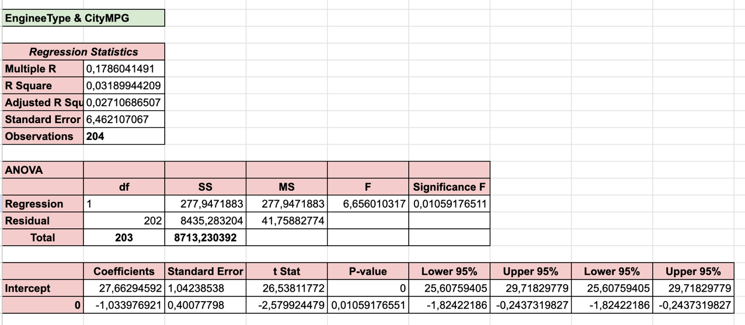
The obtained regression results must be analyzed by observing the slope, intercept, coefficient of determination (R²), and the evaluation metric (MSE). The intercept value of 27.66 suggests that when the EngineType variable is at its baseline category (e.g., zero), the predicted CityMPG is approximately 27.66. The slope coefficient of -1.03 indicates that a change in EngineType is associated with a decrease in CityMPG by around 1.03 miles per gallon, suggesting a negative relationship. The R Square (R²) value of 0.0319 implies that only about 3.2% of the variation in CityMPG can be explained by the EngineType variable, meaning the model has low explanatory power. The Mean Squared Error (MSE), calculated as the residual Mean Square (MS) value of 41.76, shows the average squared difference between the actual and predicted CityMPG values — a relatively high value, indicating limited prediction accuracy. Despite the low R², the p-value of 0.0106 and Significance F under 0.05 indicate that EngineType has a statistically significant effect on CityMPG.

- CylinderNumber
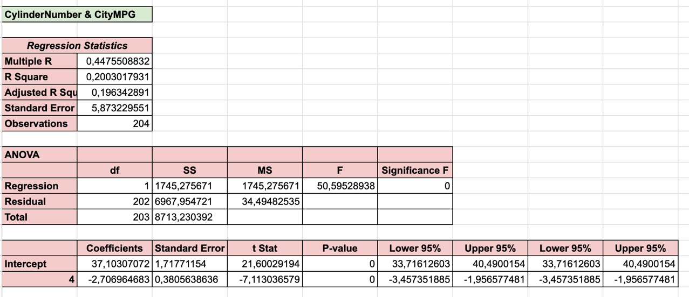
The regression results between the variables cylindernumber and citympg show a significant relationship with an R² value of 0.2003, meaning 20.03% of the variation in citympg can be explained by the cylindernumber variable. The intercept value of 37.103 indicates that when cylindernumber is 0, the estimated citympg is 37.103. Meanwhile, the slope (coefficient for cylindernumber) of -2.707 shows that for each increase of one unit in cylindernumber, citympg is expected to decrease by 2.707. The p-value for both the intercept and slope is less than 0.05, indicating that the relationship between these two variables is statistically significant. The low R² value suggests that this model only explains a small portion of the variation in citympg, indicating that other variables may have a stronger impact on citympg. With a high F-statistic (50.595) and a very low p-value, the overall regression model is considered significant. However, the relatively large standard error (5.873) indicates that predictions from this model may have considerable deviation.

- FuelSystem
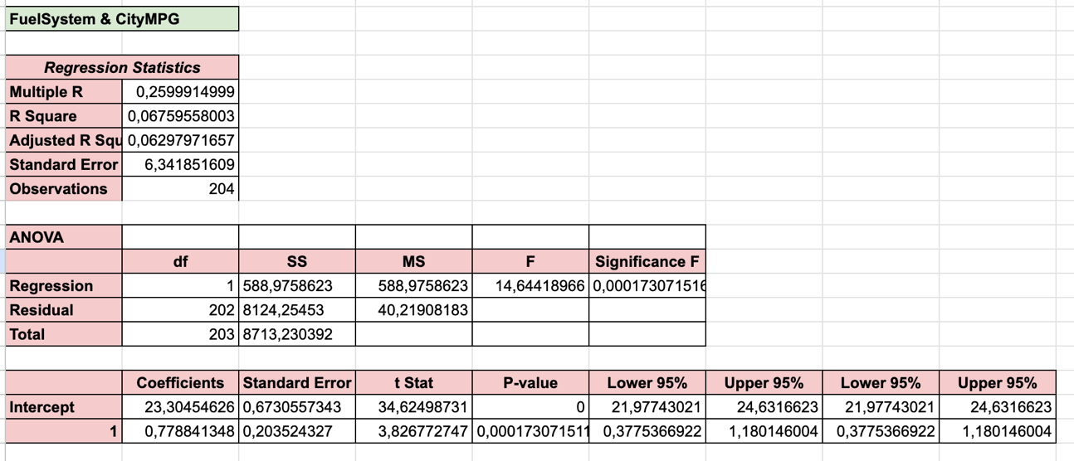
The regression results between the variables fuelsystem and citympg show a modest relationship, with an R² value of 0.0676, indicating that only 6.76% of the variation in citympg can be explained by fuelsystem. The intercept value of 23.305 suggests that when fuelsystem is 0, the estimated citympg is 23.305. The slope (coefficient for fuelsystem) of 0.779 indicates that for each increase of one unit in fuelsystem, citympg is expected to increase by 0.779. The p-value for both the intercept and the slope is less than 0.05, which means that the relationship between the two variables is statistically significant. However, the low R² value suggests that this model only explains a small portion of the variation in citympg, indicating that other factors may have a greater influence on citympg. Despite the relatively small proportion of variation explained by this model, the high F-statistic (14.644) and low p-value (0.00017) suggest that the model is statistically significant. The standard error of 6.342 indicates that predictions from this model may have considerable variability.

- HorsePower
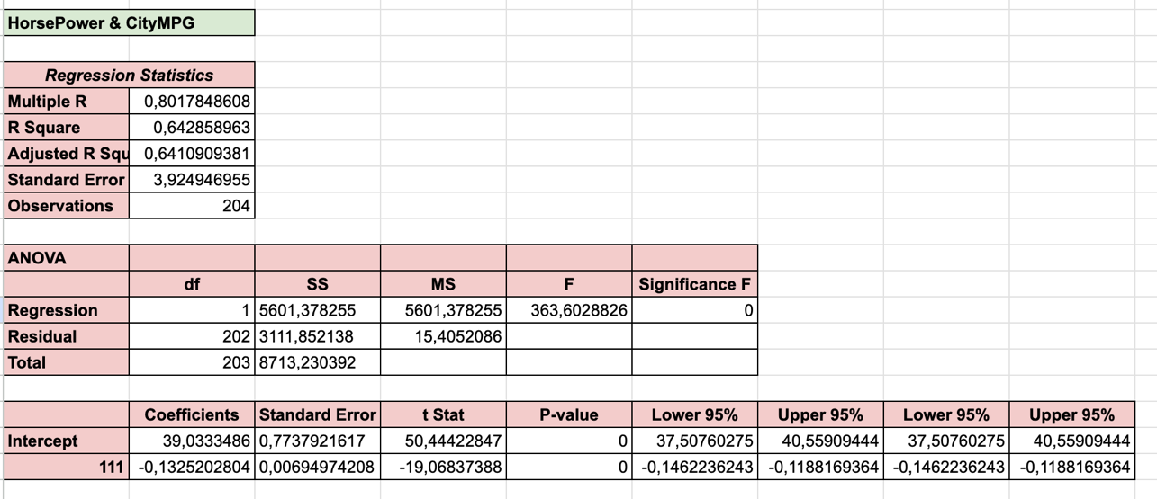
The regression results between the variables horsepower and citympg show a strong relationship with an R² value of 0.6429, meaning that 64.29% of the variation in citympg can be explained by horsepower. The intercept value of 39.033 indicates that when horsepower is 0, the estimated citympg is 39.033. The slope (coefficient for horsepower) of -0.133 shows that for each increase of one unit in horsepower, citympg is expected to decrease by 0.133. The p-value for both the intercept and slope is less than 0.05, indicating that the relationship between horsepower and citympg is statistically significant. The relatively high R² value suggests that the model explains a significant portion of the variation in citympg, indicating that horsepower is a substantial factor in determining citympg. The high F-statistic of 363.603 and the very low p-value (0) also suggest that the overall regression model is statistically significant. The standard error of 3.925 indicates that predictions from this model have relatively low variability compared to the magnitude of the estimates.

